臉部辨識解鎖

Face Lock

在此Scratch專案裡，你會實作出一隻可以使用你的臉來解鎖的虛擬手機。

In this project you will make a Scratch project that can unlock a virtual phone using your face.

你會訓練一個機器學習模型來辨識人臉，並且只有在辨識到正確的人時才解鎖手機。

You’ll train a machine learning model to be able to recognise a face so that it only unlocks the phone for the right person.

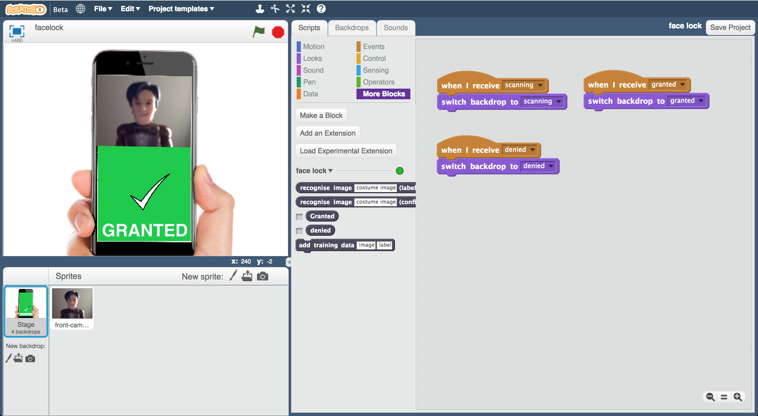

Creative Commons LicenceThis project worksheet is licensed under a Creative Commons Attribution Non-Commercial Share-Alike License

http://creativecommons.org/licenses/by-nc-sa/4.0/

此專案由Mountbatten School的Jasmine Crisp和Daniel May所完成

This worksheet was contributed by Jasmine Crisp and Daniel May, from Mountbatten School.

1. 搜尋網頁：

Go to <https://machinelearningforkids.co.uk/> in a web browser

1. 點選“**Get started**”按鈕

Click on “**Get started**”

1. 點選“**Log In**”按鈕並登入系統

*如果你沒有帳號，請你的老師幫你建立一個帳號。*

*如果你不記得你的帳號或密碼，請你的老師幫你重新設定一次*

Click on “**Log In**” and type in your username and password  
*If you can’t remember your username or password, ask your teacher or group leader to reset it for you.*

1. 點選上方清單中的 **”Projects”** 按鈕

Click on “**Projects**” on the top menu bar

1. 點選 “**+ Add a new project**” 按鈕

Click on the **“+ Add a new project**” button.

1. 將你的專案命名為 “face lock”並設定成辨識 “**images**”類別

Name the project “face lock” & set it to learn to recognise “**images**”  
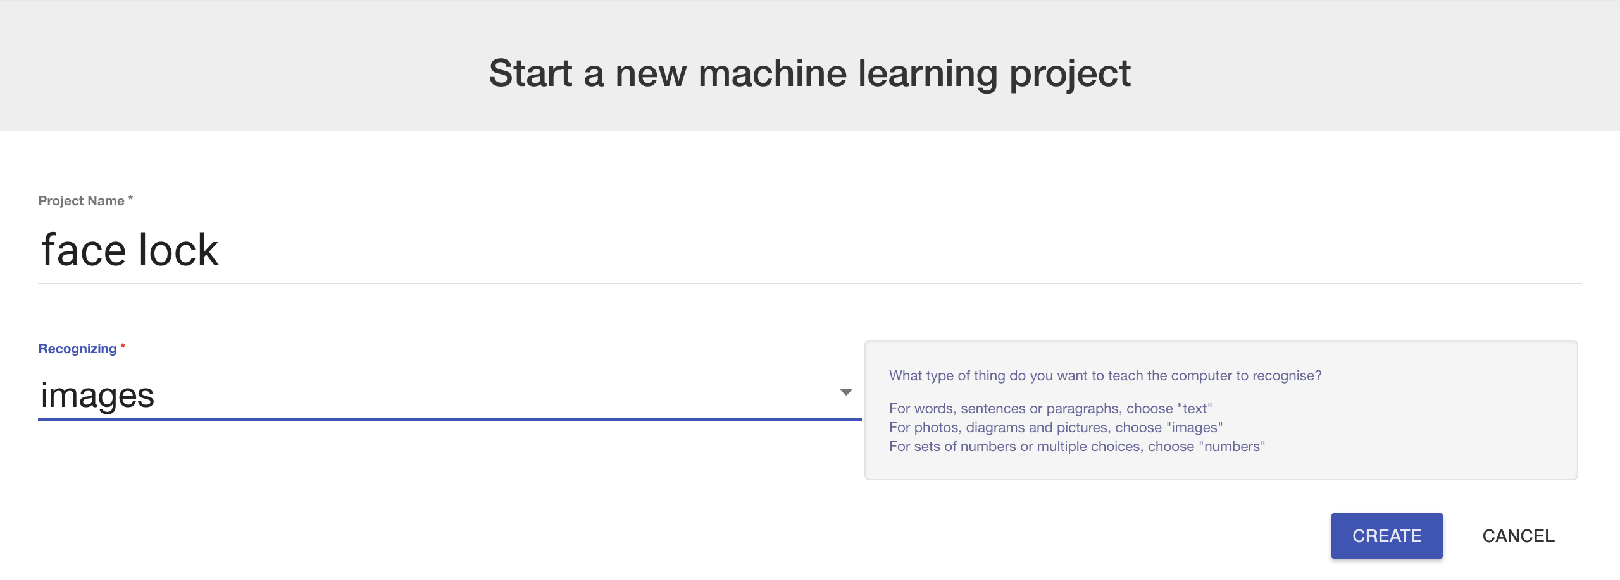

1. 你會在專案清單中看到“**face lock**”，點選此專案

You should see “face lock” in your list of projects. Click on it.

1. 點選 **”Train”** 按鈕

Click the “**Train**” button to start collecting examples  
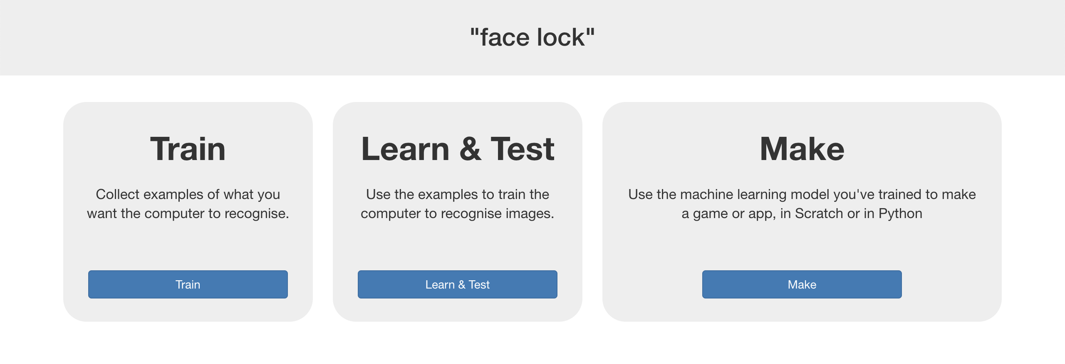

1. 點選 “**+ Add new label**”按鈕，建立一個叫“Granted”的框框

Click on “**+ Add new label**”. Create a bucket called “Granted”  
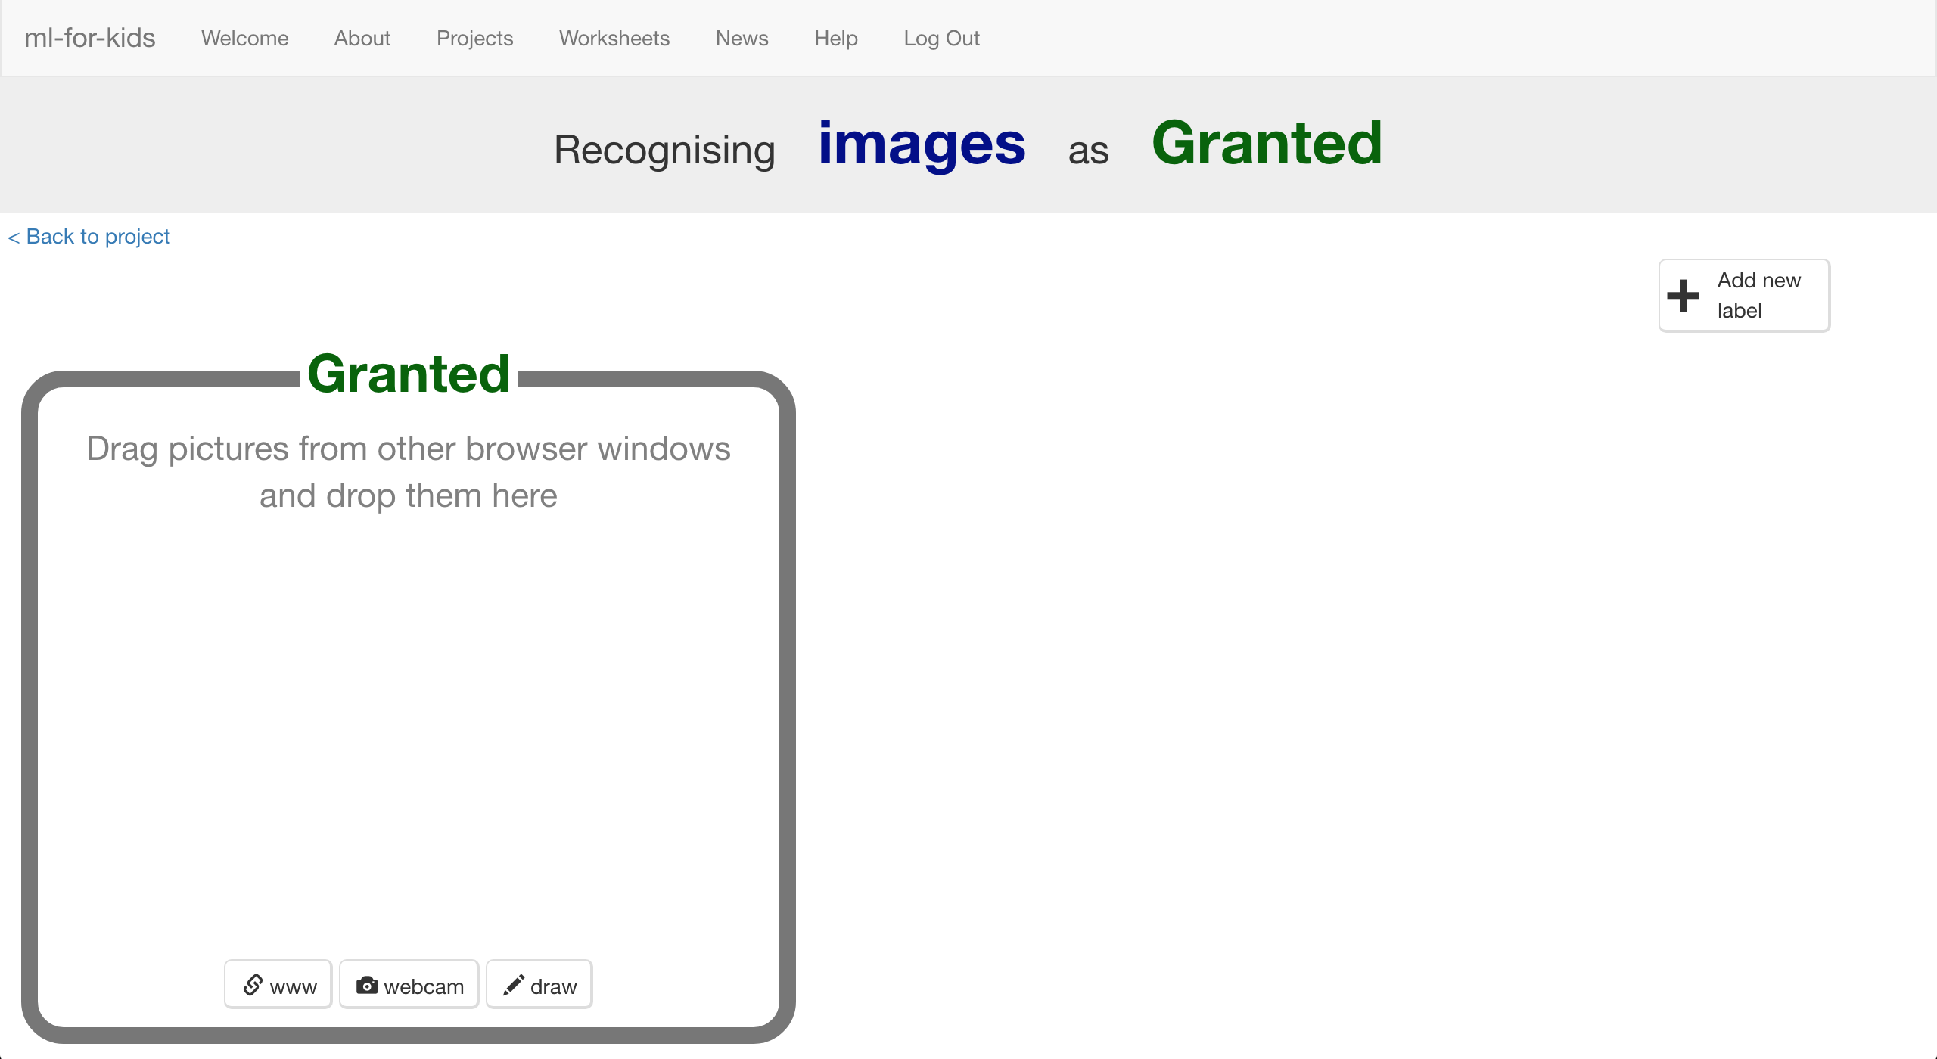

1. 點選“**webcam**”按鈕

Click “**webcam**”.   
預覽視窗裡會顯示出目前你的鏡頭所拍到的畫面

*如果你的瀏覽器要求存取權，點選『允許』*

A preview window will show the current view from your webcam.  
*You will need to click “Approve” or “Allow” if your web browser asks permission to use your webcam.*

1. 將你的臉移動到鏡頭前，按下“**Add**”拍張照

Put your face in front of the webcam, and click “**Add**” to take a picture of it.   
*如果你不能/不想上傳你自己的照片，可以用玩具替代*

*Make sure you have permission to upload photos of your face. If you don’t, use a toy with a face like we’ve done here.*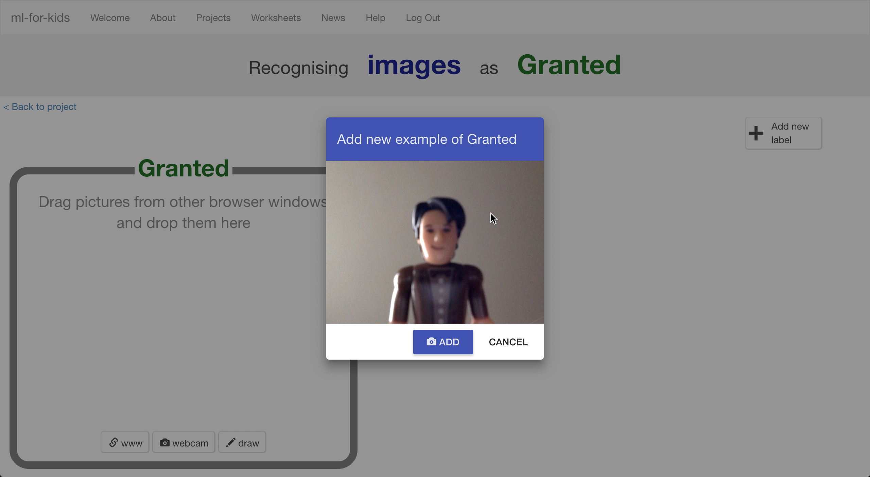

1. 重複上個步驟直到至少有10張你的臉的照片

Repeat until you’ve got at least 10 examples of your face.   
*盡量讓照片有不同的背景、角度和遠近距離。差異性越高的照片越好*

*Take pictures with different backgrounds, angles, focuses, and distances from the webcam. The more variation the computer has to learn from, the better.*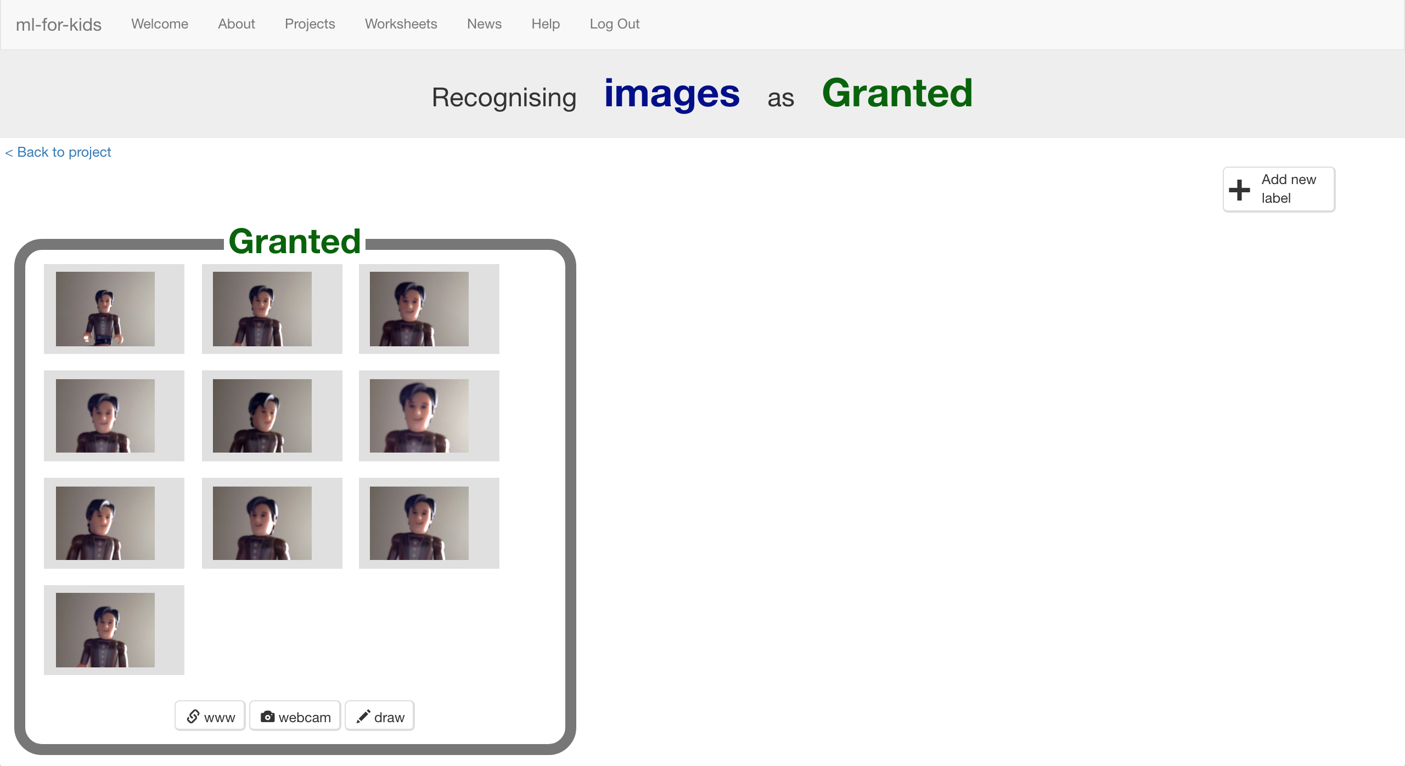

1. 點選 “**+ Add new label**”按鈕，建立一個叫“denied”的標籤

Click “**+ Add new label**” and create one called “denied”

1. 點選“denied”框框下方的“**webcam**”按鈕，拍10張其他人的臉

Use the “**webcam**” button in the “denied” bucket to take 10 photos of other people’s faces  
*如同剛剛拍攝自己的照片一樣，從不同背景、角度、距離去拍別人的照片*

*Try to vary these pictures in the same way that you varied your first set.*

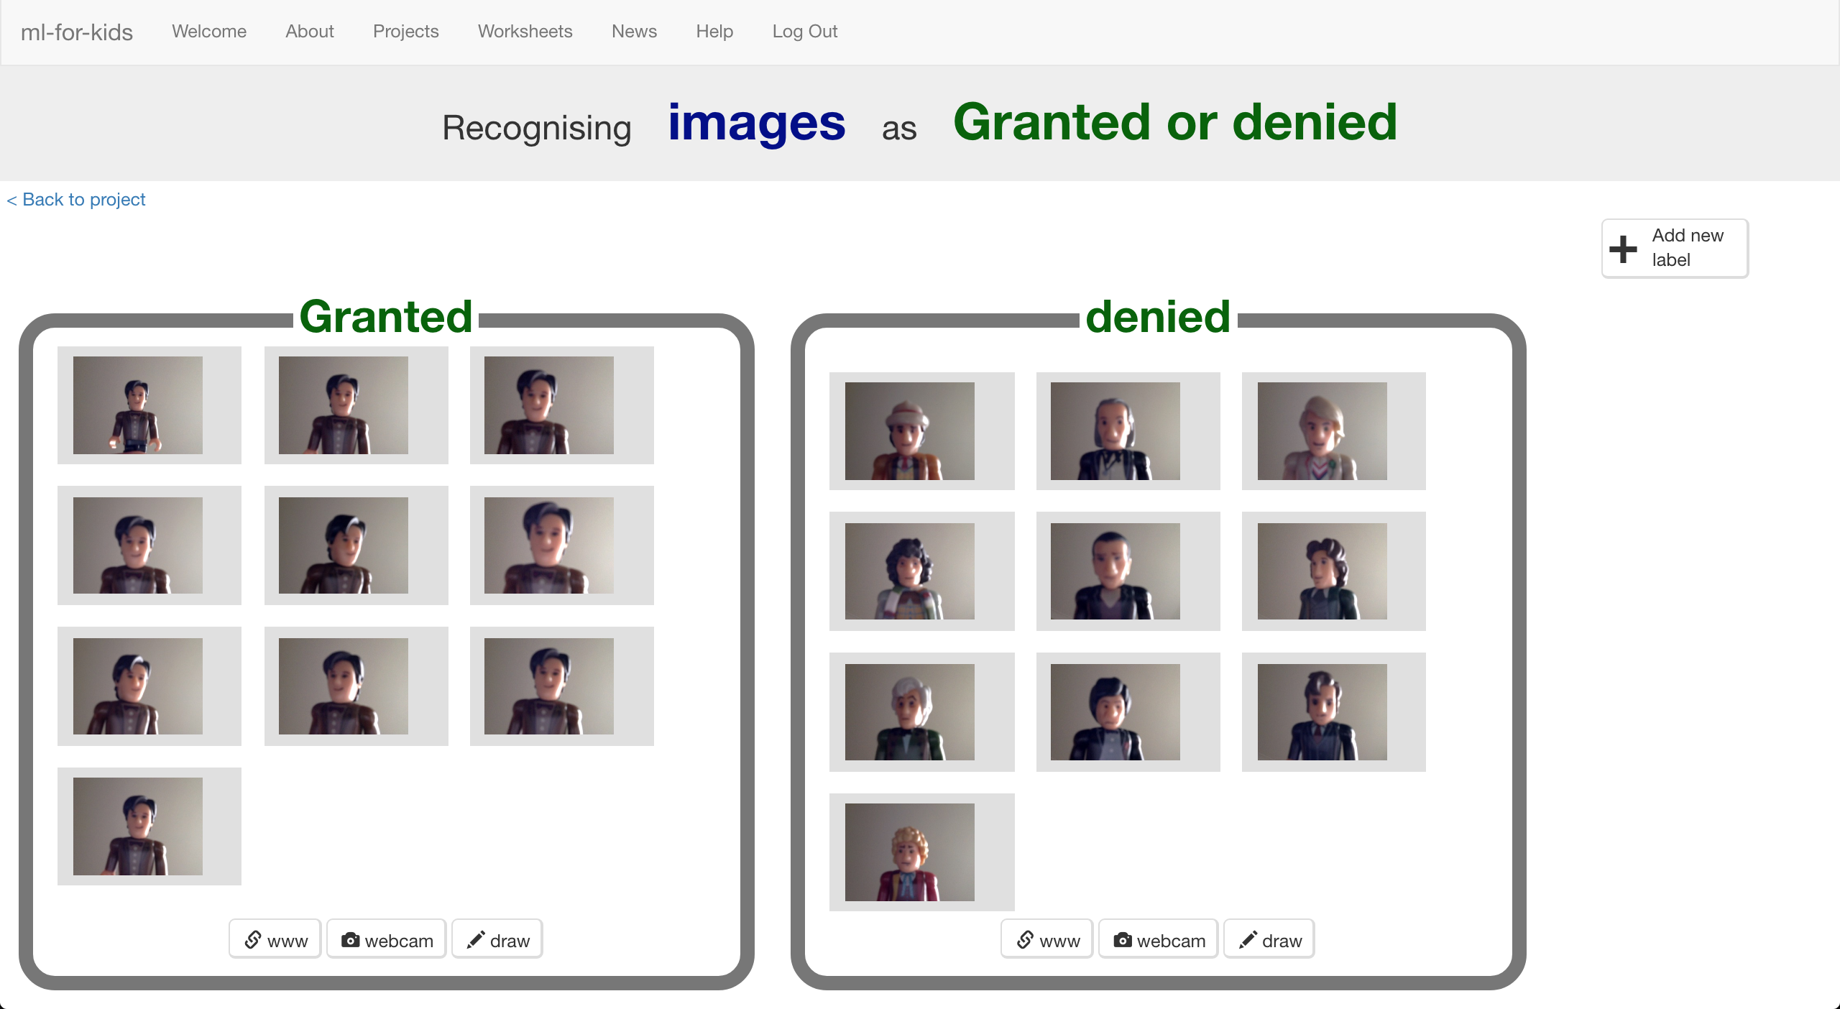

1. 點選“**< Back to project**”

Click on the “**< Back to project**” link

1. 點選“**Learn & Test**”按鈕

Click the “**Learn & Test**” button

1. 點選“**Train new machine learning model**”按鈕

Click the “**Train new machine learning model**” button  
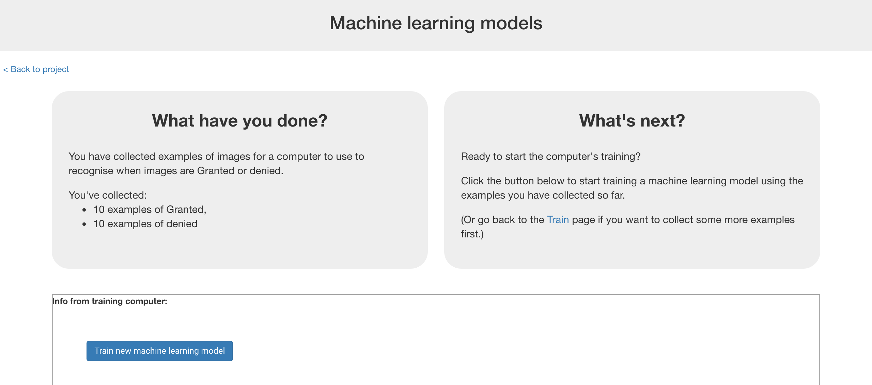

1. 等待訓練完成

*此步驟可能需要花費幾分鐘的時間*

Wait for the training to complete.   
*This might take a few minutes. You’ll know when it’s done when it gives you the opportunity to test the model. Why not try doing the quiz?*

1. 點選“**< Back to project**”

Click on the “**< Back to project**” link

**你完成了什麼？**

**What have you done so far?**

你已經開始訓練電腦辨識你的照片了

You’re started to train a computer to recognise pictures of you.

但你不是採用寫規則的方式來訓練，而是使用蒐集你自己的照片的方式。

這些蒐集來的範例會被用來訓練一個機器學習的 『模型』，此方法稱為『監督式學習』(supervised learning)，因為你給電腦訓練用的範例都確保是正確的，就像是在監督它一樣。

Instead of trying to write rules to be able to do this, you are doing it by collecting pictures of yourself.

These examples are being used to train a machine learning “model”. This is called “supervised learning” because of the way that you are supervising the computer’s training.

電腦會從你給的範例照片中學習到一些模式。我們希望它會學到的是臉部特徵或頭髮，但也要記得它可能會學到衣服或背景等模式。

The computer will learn from the patterns in the photos you’ve taken. Hopefully this will mostly be the facial features and hair, but beware that it might also include the clothes and background!

1. 點選“**Make**”按鈕

Click the “**Make**” button

1. 點選“**Scratch**”

Click the **Scratch** button.

1. 點選**Open in Scratch**

Click the **Open in Scratch** button.  
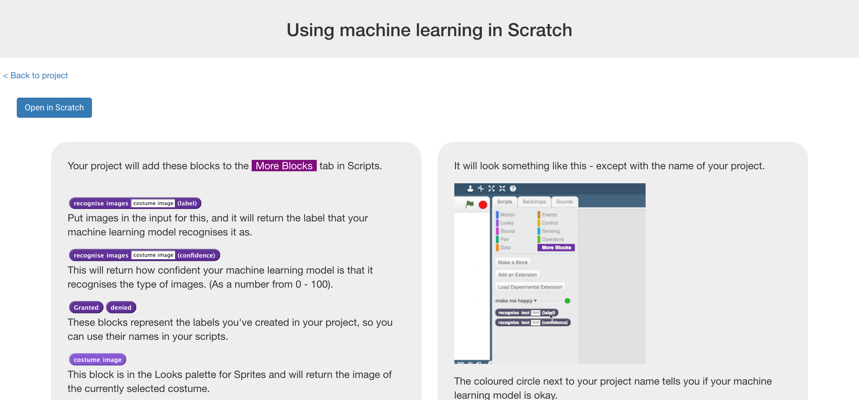

1. 載入Face Lock專案

*點選****Project templates，****再點選****Face Lock***

Load the Face Lock template project  
*Click* ***Project templates*** *->* ***Face Lock*** *as shown below*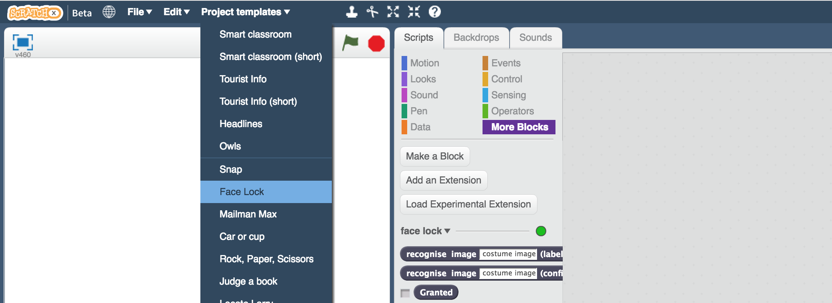

1. 拖曳程式積木（如下圖）

Create this script  
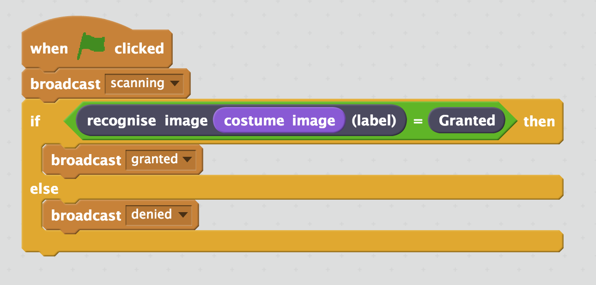

1. 點選『造型』，再點選 『從攝影裝置錄製新造型』

Click on the “**Costumes**” tab,   
then click on the “**New costume from camera**” button  
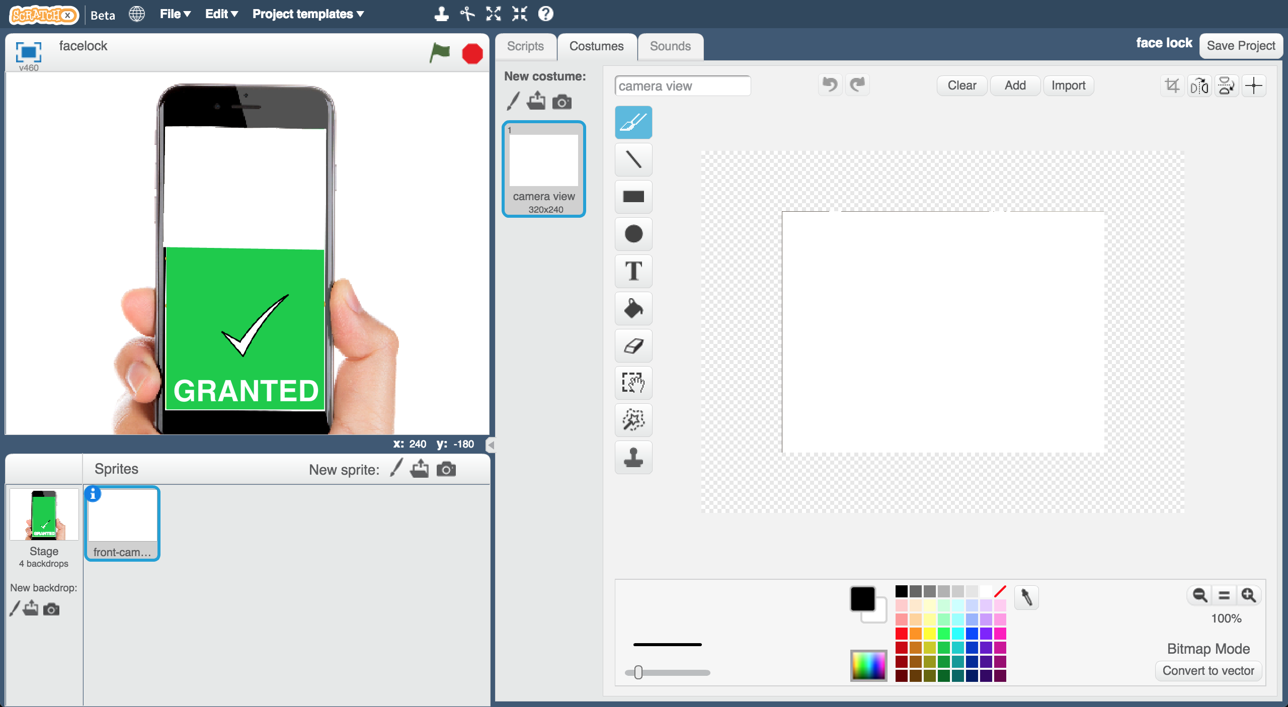

1. 使用攝影鏡頭拍一張不被允許解鎖手機的人臉照片

Use the webcam to take a photo of a face that should not be allowed to use the phone  
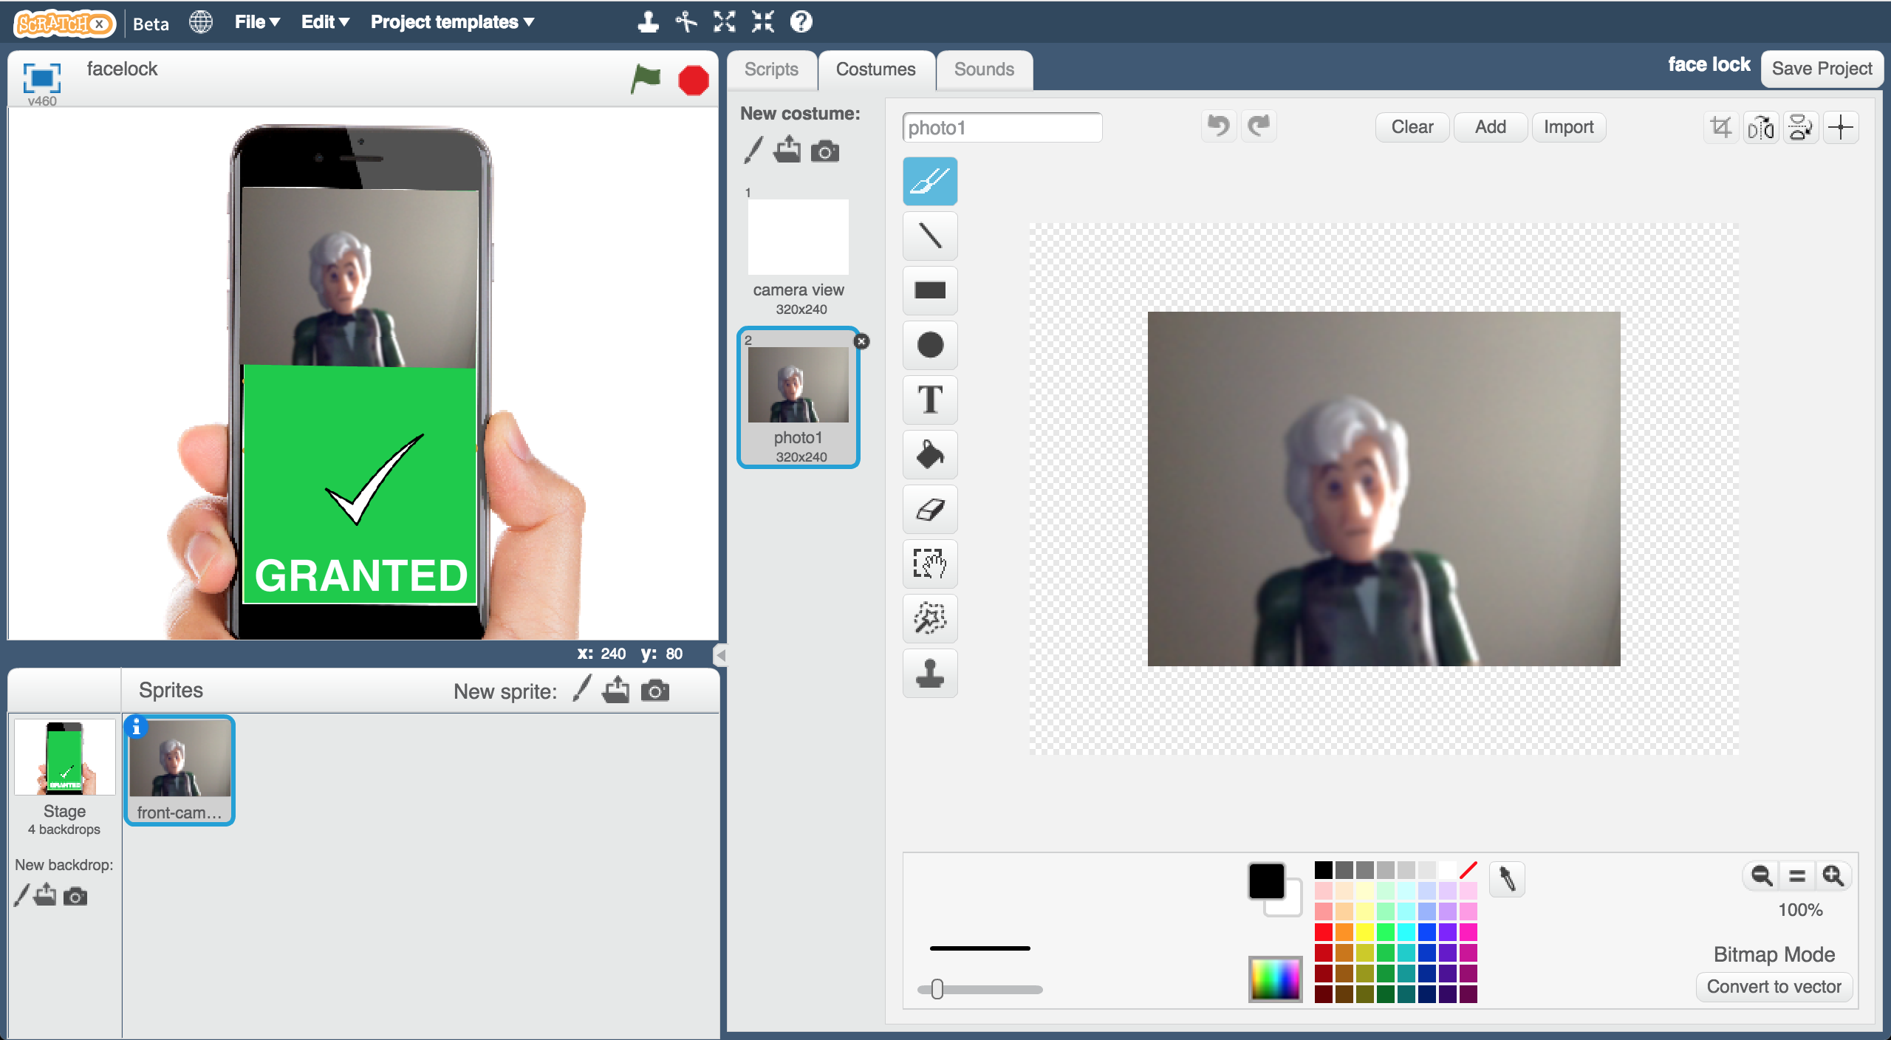

1. 再次點選 『從攝影裝置錄製新造型』，拍一張可允許解鎖手機的人臉照片

Click the “**New costume from camera**” button again, and take a photo of a face that should be allowed to use the phone   
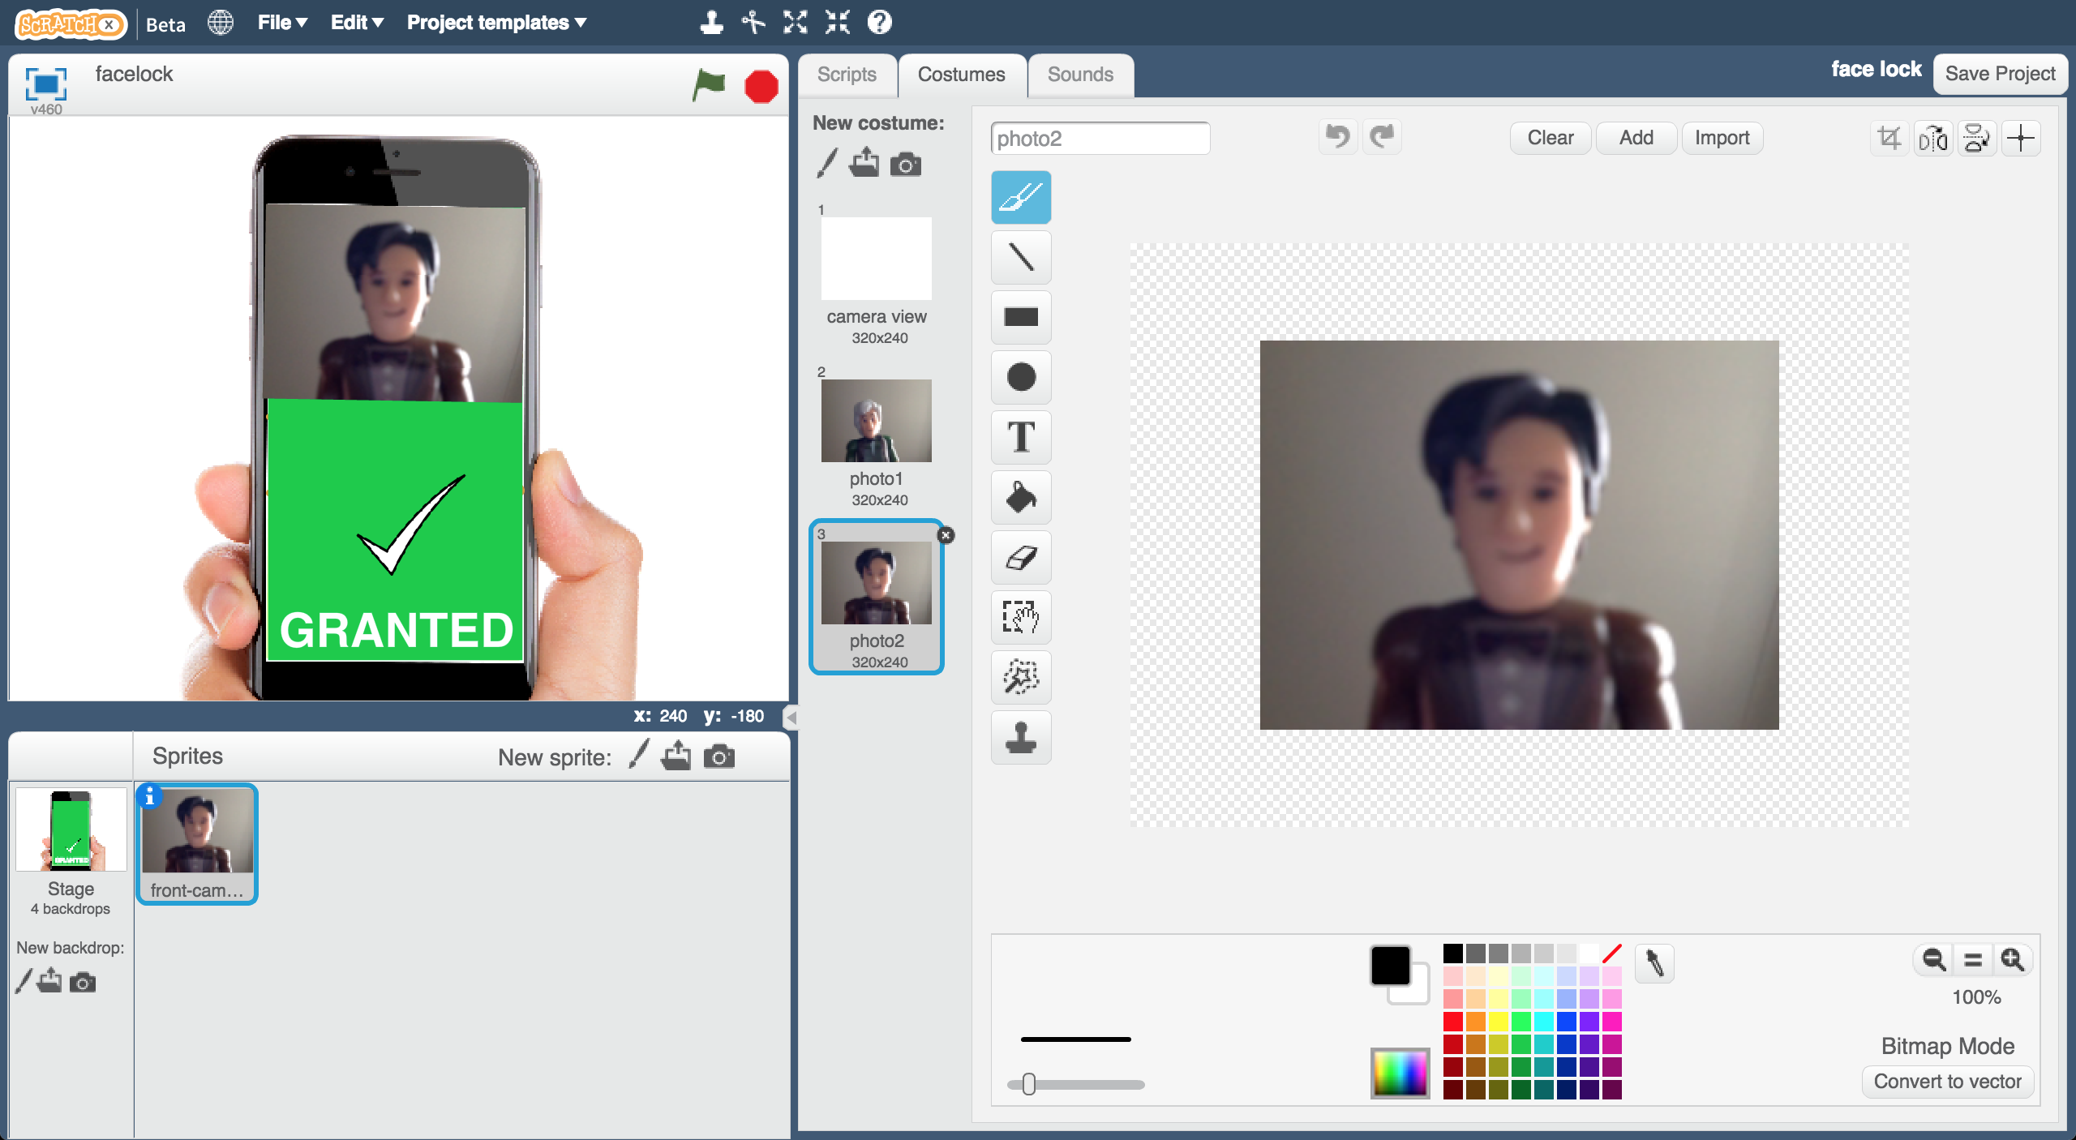

1. 點選『舞台』

Click on the **Stage**   
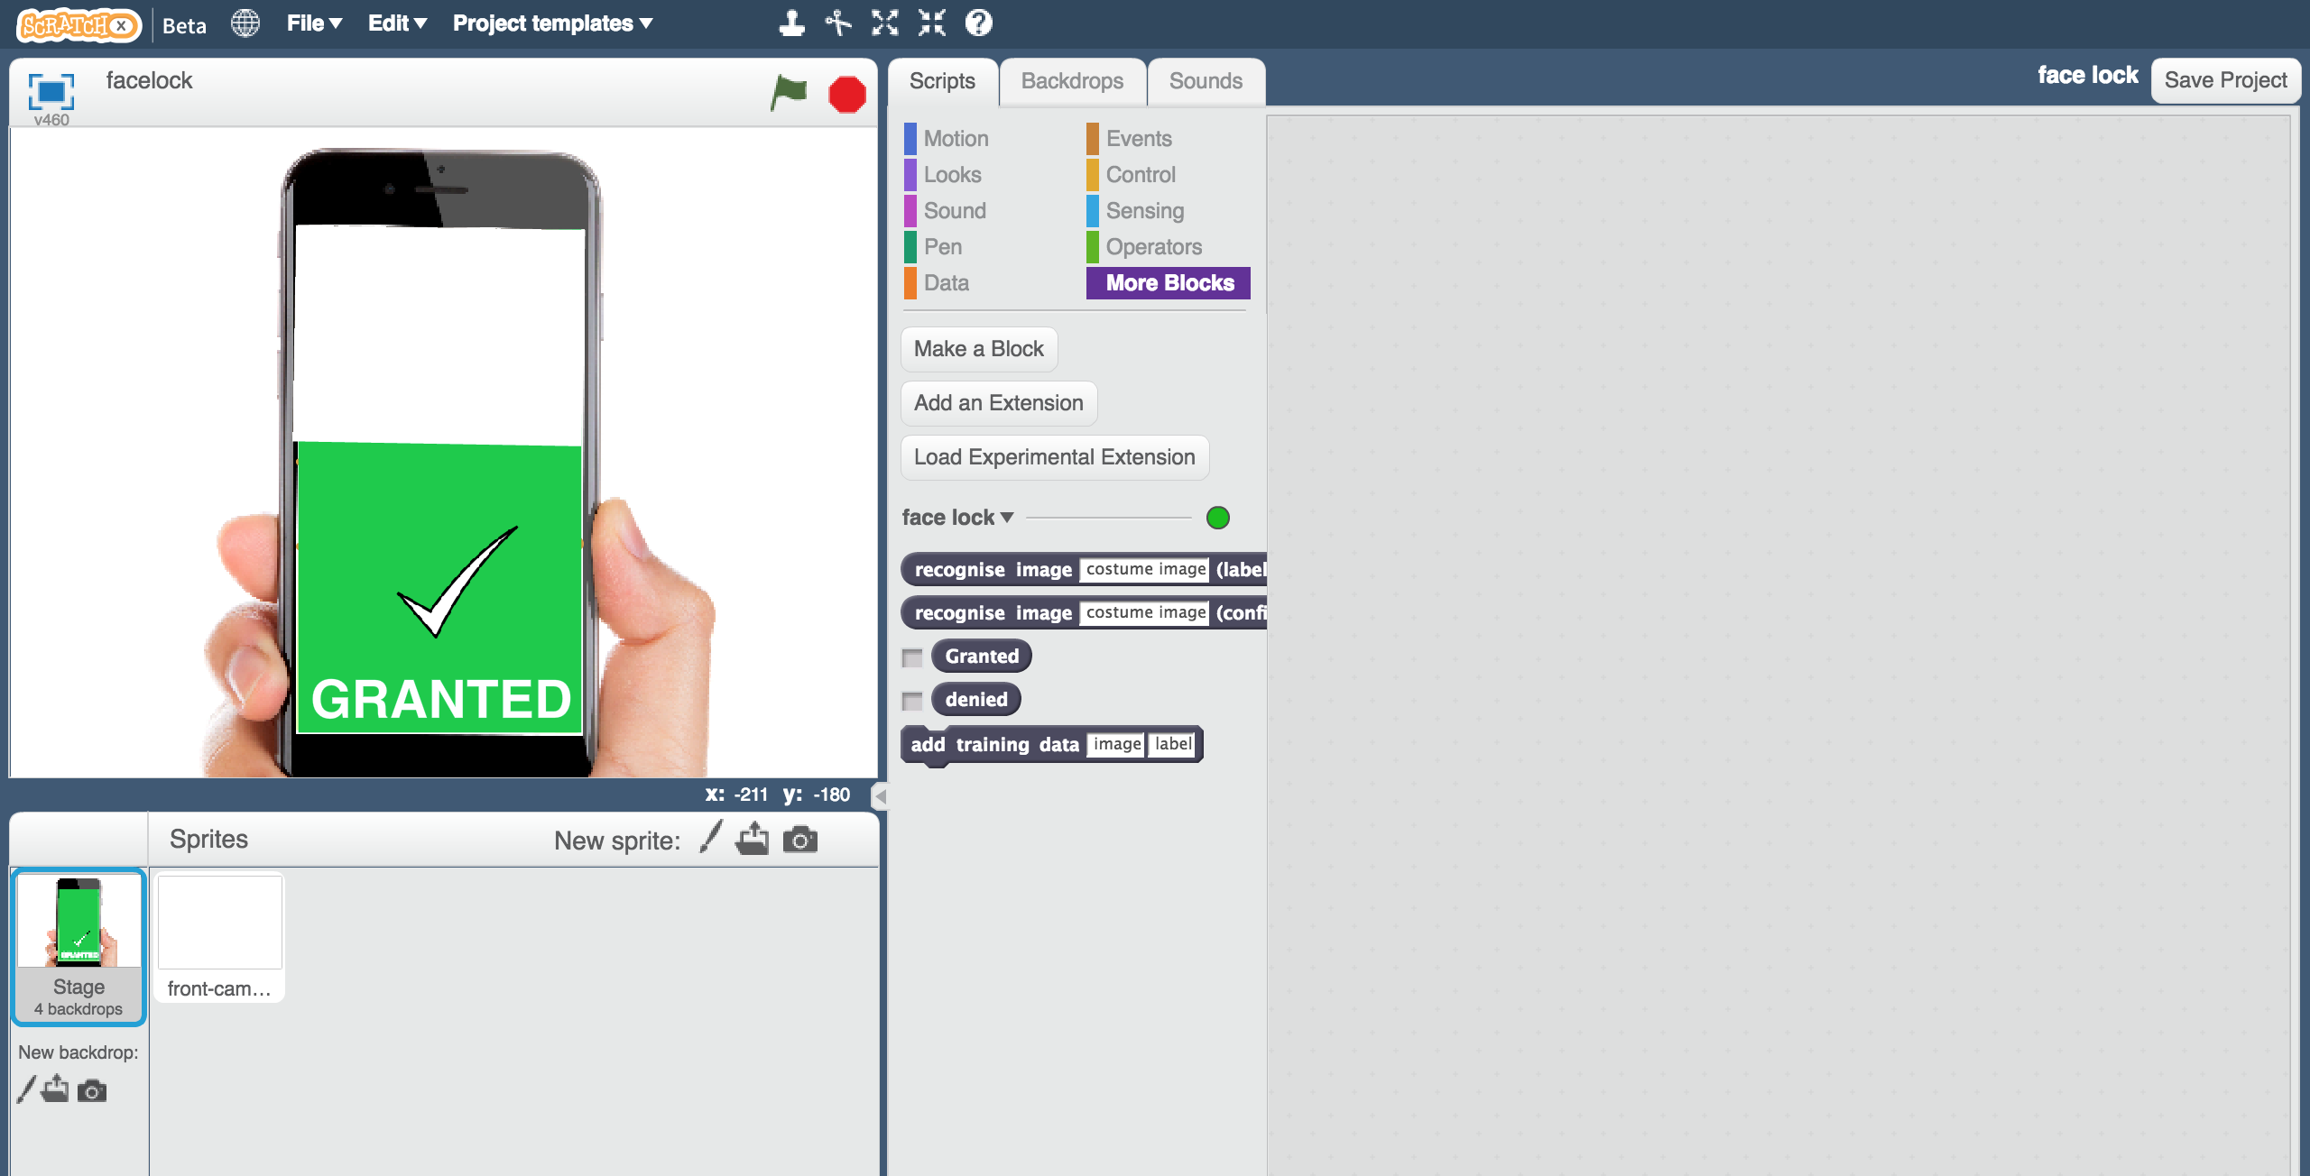

1. 拖曳程式積木（如下圖）

*這些程式可以控制手機螢幕，使其顯示不同的鎖定狀態。*

Create the following scripts  
*These will make the phone screen update based on whether it is locked.*  
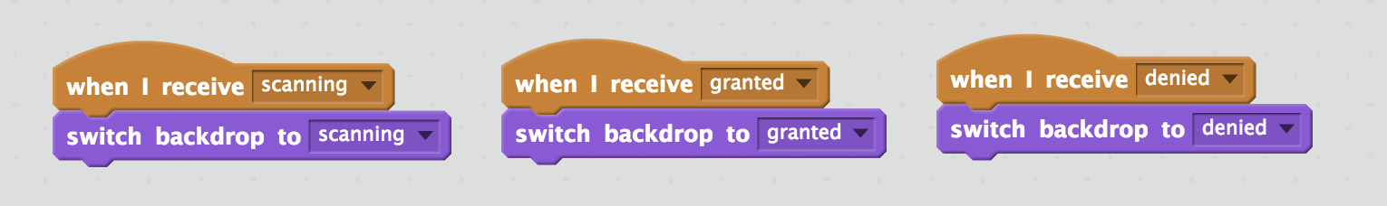

1. 測試時間到！點擊綠旗

It’s time to test! Click the green flag  
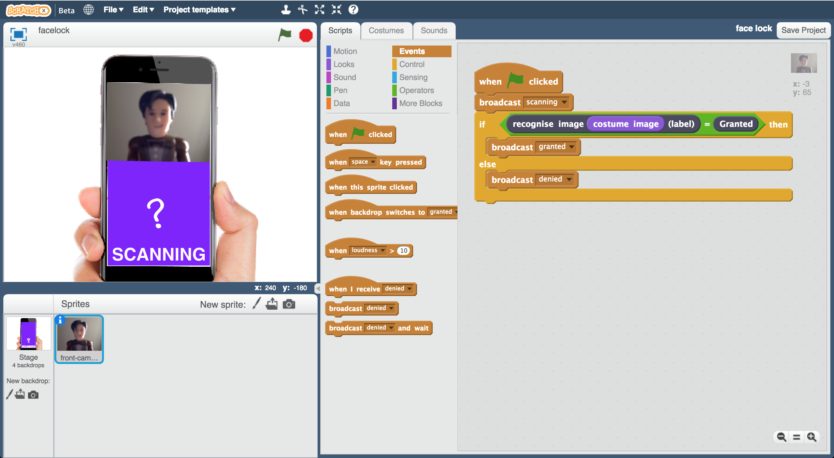

**你完成了什麼？**

**What have you done?**

你利用不同的臉部照片訓練了一個機器學習模型，打造出一個臉部辨識系統。

You’ve trained a facial recognition system. You’ve done this by collecting examples of pictures of faces, and used this to train a machine learning model that is able to recognise faces.

這個機器學習模型被應用在我們的App中作為登入的機制（藉此來確認，這人是否符合他所宣稱的身分）。

You’ve used this model to create an app, using the model as an authentication method (a way of proving that someone is who they say they are).

到目前為止，這是一個非常簡單的系統

It’s a very simple system so far.

你能想出一些讓電腦搞混的方法嗎？

Can you think of ways that you could fool it?

**延伸活動**

**Ideas and Extensions**

**如果電腦不確定怎麼辦？**

**What if the computer isn’t sure?**

下面這個積木(confidence block)回傳的是系統對成功辨識出一張臉的信心程度（一個從0到100的數字）

The confidence block returns a percentage (a number from 0 to 100) with how confident it is that it has recognised the face.

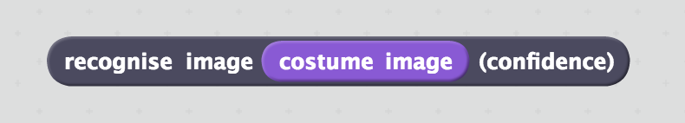

你可以如何使用這個積木來更新你前面的程式？

How could you update your script to use this?

如果電腦只有10%的把握現在辨識到的是其他人的臉，那手機螢幕要不要解鎖呢？

Should the phone still unlock if the computer is only 10% sure that it has correctly recognised the owner’s face?

**加入更多可被允許解鎖的人**

**Add more people for the computer to accept**

你有辦法讓手機辨識出兩張不同，但都可以解鎖手機的人臉嗎？

Can you get the phone to recognise two different people’s faces that it should let through?

**試著搞混電腦**

**Try confusing the computer**

如果你訓練電腦的照片都只在同一個地方，當你換到另一個地方時，電腦還是能成功辨識出你的臉嗎？如果你換一件衣服呢？

If you train the computer to recognise you while you’re in one place only, can it still recognise you if you are somewhere else? What if you change your clothes?

電腦是在辨識你的臉還是在辨識其他東西呢？  
Is the computer recognising your face, or something else?

試著找出電腦是如何學習以及如何表現的

Experiment to find out how the computer learns and how it behaves.

**你知道嗎？**

**Did you know?**

第一位嘗試臉部辨識的是1965年的Woodrow Wilson Bledsoe。他手動輸入並儲存了一些人的臉部數據

The first known attempt at facial recognition was in 1965 by Woodrow Wilson Bledsoe. He manually inputted measurements of a person’s face and stored them, along with measurements of other people’s faces.

當有一張新的照片時，系統可以辨識出這張照片最有可能是誰的臉

When presented with a new photograph, the system could be used to work out which person most closely resembled the picture.

他在設法解決辨別頭部的旋選角度、傾斜度、光的強度與角度、年紀、臉部表情和其他因素的差別時遇到一些困難，這些問題在當時還無法解決。

He found a number of issues with getting his system to cope with differences in “head rotation, tilt, light intensity, the angle of the light, aging, facial expression” and a number of other factors. These were impossible to avoid at the time.

近期，Apple將他們的手機加入了臉部辨識的功能，也就是Face ID。他們不仰賴照片，而是將你的臉劃分成一張超過30,000點的細緻地圖。這方法可以協助辨別你臉部的微小變化，像是是否有化妝，或者是否改變了髮型。其他公司，比如Samsung，也在他們的手機上加入了類似的功能。

Recently, Apple introduced facial recognition into their phones, by using software known as Face ID. Instead of relying on pictures, this makes a detailed map of over 30,000 specific points on your face. This helps it to handle small changes in the look of your face, such as wearing makeup or a different hairstyle. Other companies, such as Samsung, have also introduced similar technology to their phones.